MACHINE LEARNING

1.What is Machine Learning?
- Machine Learning (ML) is a subset of Artificial Intelligence (AI) that involves the development of algorithms and statistical models that enable machines to perform tasks without being explicitly programmed.
- In other words ML allows computers to learn from data and improve their performance on a task over time, without being explicitly told what to do.

Real-World Examples of Machine Learning:
- Virtual Assistants: Siri, Google Assistant, and Alexa use ML to understand voice commands and respond accordingly.

- Image Recognition: Facebook's facial recognition feature uses ML to identify and tag friends in photos.

- Predictive Maintenance: Companies like GE and Siemens use ML to predict when equipment is likely to fail, allowing for proactive maintenance.

- Recommendation Systems: Netflix and Amazon use ML to suggest movies and products based on user behavior and preferences.

- Self-Driving Cars: Companies like Waymo and Tesla use ML to enable autonomous vehicles to navigate roads and make decisions in real-time.

2.Types of Machine Learning:
There are three main types of Machine Learning: Supervised Learning, Unsupervised Learning, and Reinforcement Learning.
1. Supervised Learning:
- Definition: The model is trained on labeled data, where the correct output is already known.
- Example: Image Classification - a machine is trained on a dataset of images labelled as "cats" or "dogs" to learn to classify new images as either cats or dogs.
- Usually there are two problems comes under Supervised
1.Regression.
2.Classification.

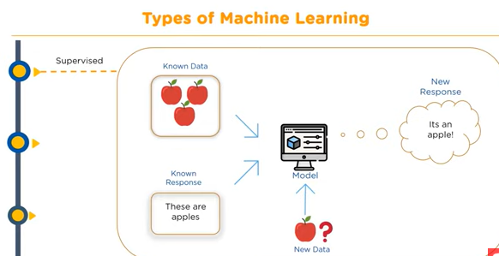

2. Unsupervised Learning:
- Definition: The model is trained on unlabeled data, and it must find patterns in the data on its own.
- Example: Customer Segmentation - a machine is trained on a dataset of customer information (e.g. age, location, purchase history) to identify clusters of similar customers.
- The types of unsupervised learning are
- Clustering.
- Association Analysis
- Dimensionality reduction.

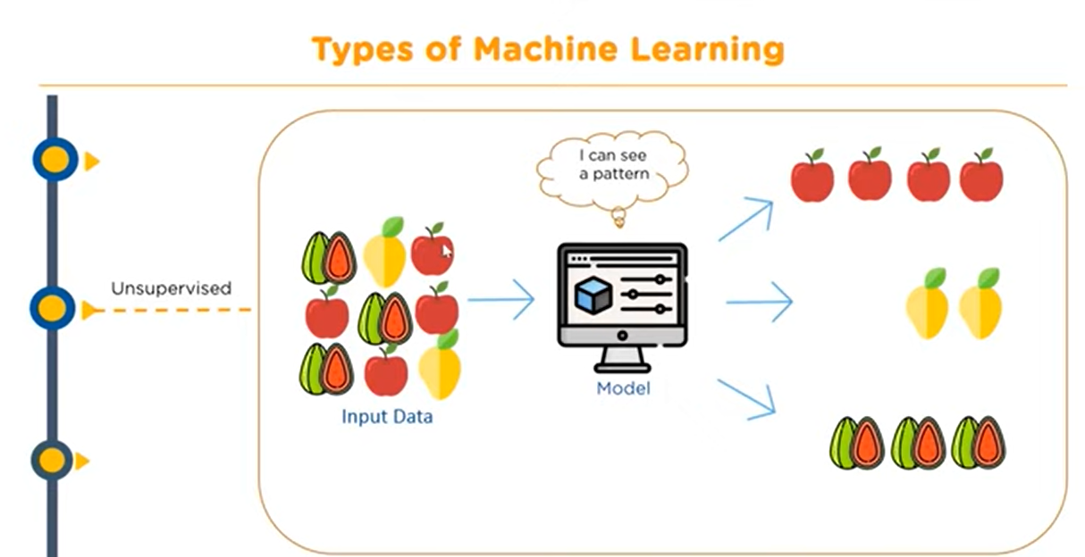
3. Reinforcement Learning:
- Definition: The machine learns by interacting with an environment and receiving rewards or penalties for its actions.
- Example: Game Playing - a machine is trained to play a game like chess or Go by receiving rewards for winning and penalties for losing, and it must learn to make decisions to maximize its rewards over time. Example: Q-learning etc.

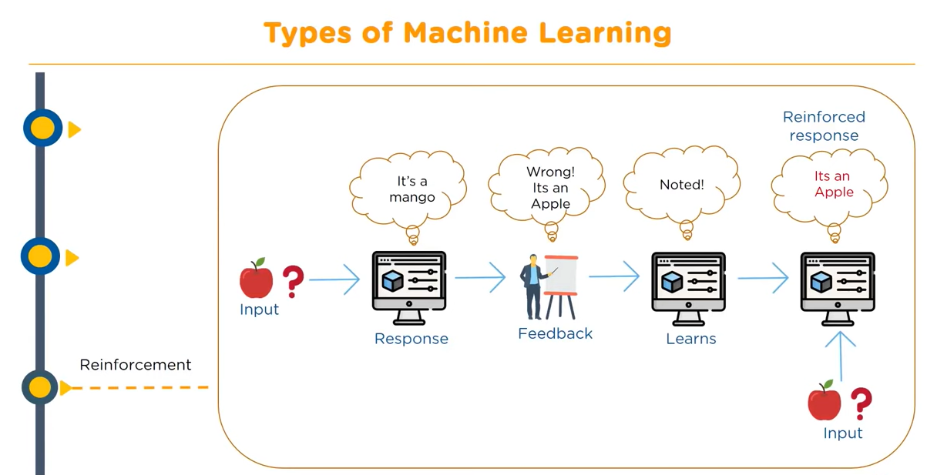

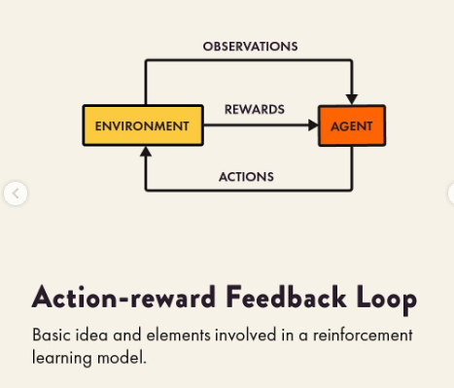

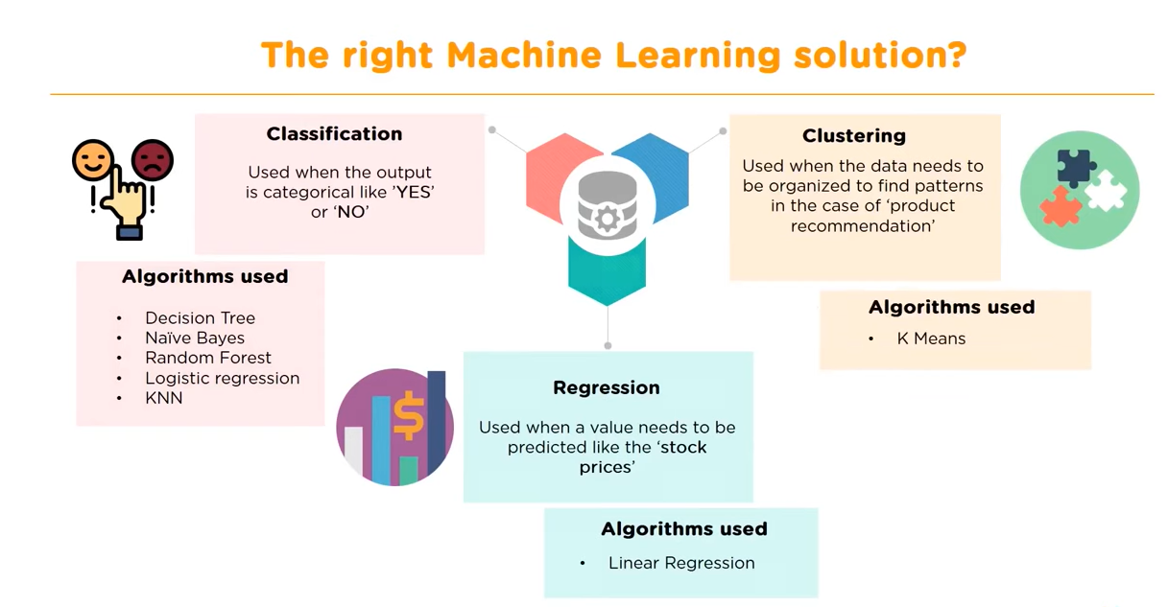

3.Comparing Types of Machine Learning
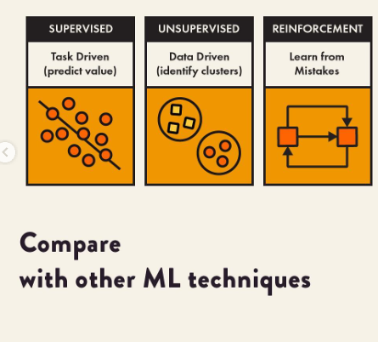

4. Process of preparing Machine Learning Model
Following are the typical preparation activities done once the input data comes into the machine learning system:
Activities in Machine Learning
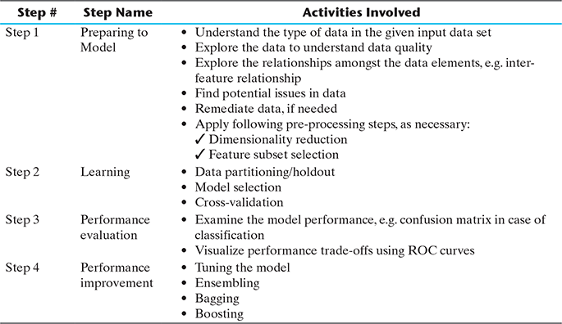
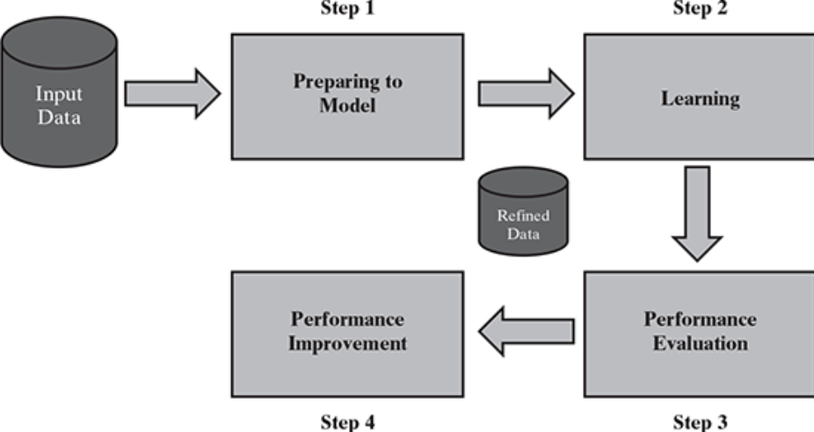
FIG. Detailed process of machine learning

5.BASIC TYPES OF DATA IN MACHINE LEARNING
Dataset: A data set is a collection of related information or records.
Here is the snapshot of sample dataset related to diabetes.

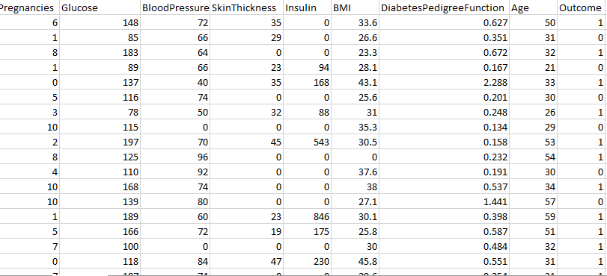

- Column in data set also called feature, field, variable, characteristic, Predictor, attribute and Dimension etc.
- Row in the dataset also called as observation, record, sample,
tuple, datapoint.
- Fig: types of data
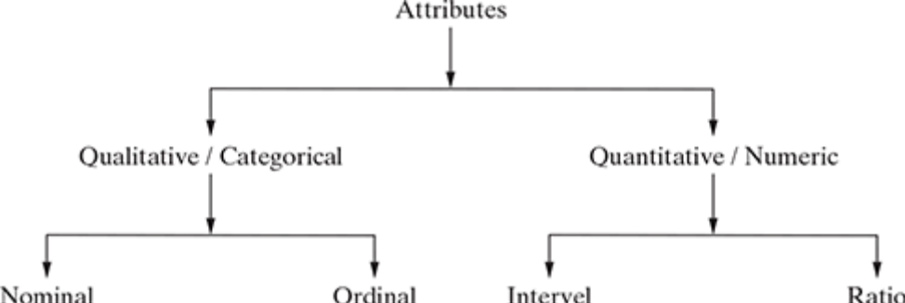
Data can broadly be divided into following two types:
1. Qualitative data
2. Quantitative data
1.Qualitative data provides information about the quality of
an object or information which cannot be measured.
- For example, if we consider the quality of performance of students in terms of ‘Good, ‘Average, and ‘Poor, it falls under the category of qualitative data.
- Qualitative data is also called categorical data.
Qualitative data can be further subdivided into two types as
follows:
1. Nominal data
2. Ordinal data
- Nominal data is one which has no numeric value, but a
named value. It is used for assigning named values to
attributes. Nominal values cannot be quantified.
- Examples of nominal data are
1. Blood group: A, B, O, AB, etc.
2. Nationality: Indian, American, British, etc.
3. Gender: Male, Female, Other
- We cannot perform any mathematical operations and statistical methods on Nominal data. Except we can count i.e Mode or frequency

- Ordinal data, ordinal data also assigns named values to attributes but unlike nominal data, they can be arranged in a sequence of increasing or decreasing value so that we can say whether a value is better than or greater than another value.

- Examples of ordinal data are
1. Customer satisfaction: Very Happy, Happy, Unhappy, etc.
2. Grades: A, B, C, etc.
3. Hardness of Metal: Very Hard’, ‘Hard’, ‘Soft’, etc.
2.Quantitative data relates to information about the quantity of an object – hence it can be measured.
- Quantitative data is also termed as numeric data. There are two types of quantitative data:
1. Interval data
2. Ratio data
Interval data is numeric data for which not only the order
is known, but the exact difference between values is also
known.
- For example, the difference between 12°C and 18°C degrees is measurable and is 6°C as in the case of difference between 15.5°C and 21.5°C. Other examples include date, time, etc
Ratio data represents numeric data for which exact value can be measured. Examples of ratio data include height, weight, age, salary, etc..
- In general, nominal and ordinal attributes are discrete. On the other hand, interval and ratio attributes are continuous.

6.DATA QUALITY AND REMEDIATION
- Data quality:
Success of machine learning depends largely on the quality of
data. A data which has the right quality helps to achieve better prediction accuracy, in case of supervised learning. We
have already come across at least two types of problems:
- Certain data elements without a value or data with a missing value.
- Data elements having value surprisingly different from the other elements, which we term as outliers
2 . Data remediation:
We will discuss how to handle outliers and missing values.
2.1 Handling outliers:
- Outliers are data elements with an abnormally high value which may impact prediction accuracy, especially in regression models.
- Once the outliers are identified and the decision has been taken to amend those values, you may consider one of the following approaches.
1.Remove outliers: If the number of records which are outliers is not many, a simple approach may be to remove them.
2.Imputation: One other way is to impute the value with mean or median or mode. The value of the most similar data element may also be used for imputation.
3.Capping: For values that lie outside the 1.5|×| IQR limits, we can cap them by replacing those observations below the lower limit with the value of 5thpercentile and those that lie above the upper limit, with the value of 95th percentile.

Handling Missing values:
The below are the techniques to handle missing values
1.Eliminating the missing values: if they are not many.
2.Imputation of missing value: we will replace or impute with mean or median or mode.
3.Estimate that missing values: we will estimate that missing values based on the observation of the dataset.

7.DATA PRE-PROCESSING

- Dimensionality reduction:
Dimensionality reduction refers to the techniques of reducing the dimensionality(number of columns) of a data set by creating new attributes by combining the original attributes.
- The most common approach for dimensionality reduction is known as Principal Component Analysis (PCA).
- PCA is a statistical technique to convert a set of correlated variables into a set of transformed, uncorrelated variables called principal components.

2.Feature subset selection:
Feature subset selection or simply called feature selection, try to
find out the optimal subset of the entire feature set which significantly reduces computational cost without any major impact on the learning accuracy.

Supervised Learning
Supervised learning can be sub divided into two types
- Regression
- Classification

1.Regression Problem:
- The problems related to prediction of numerical value can be
solved using the regression model.
- In the context of regression, dependent variable (Y) is the one whose value is to be predicted.
- This variable is presumed to be functionally related to one (say, X) or more independent variables called predictors.
- Regression is essentially finding a relationship(or) association between the dependent variable (Y) and the independent variable(s) (X), i.e. to find the function ‘f ’ for the association
Y = f (X).
The most common regression algorithms are
- Simple linear regression
- Multiple linear regression
- Polynomial regression
- Multivariate adaptive regression splines
- Logistic regression
- Maximum likelihood estimation (least squares)

1.Simple Linear Regression

- Simple linear regression is the simplest regression model which involves only one predictor.
- This model assumes a linear relationship between the dependent
variable and the predictor variable as shown in Figure below.

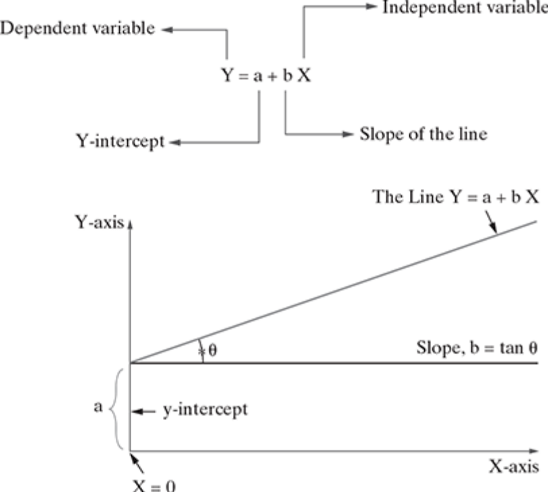

Fig. Simple Linear Regression

Error in simple regression
- The regression equation model in machine learning uses the
above slope–intercept format in algorithms.
- X and Y values are provided to the machine, and it identifies the values of a (intercept) and b (slope) by relating the values of X and Y.
- However, identifying the exact match of values for a and b is
not always possible.
- There will be some error value (ɛ) associated with it. This error is called marginal or residual error.
Y = (a + bX) + ε

To build a simple linear regression model for a given problem, it is time to summarize the algorithm.

OLS algorithm
Step 1: Calculate the mean of X and Y
Step 2: Calculate the errors of X and Y
Step 3: Get the product
Step 4: Get the summation of the products
Step 5: Square the difference of X
Step 6: Get the sum of the squared difference
Step 7: Divide output of step 4 by output of step 6 to calculate ‘b’
Step 8: Calculate ‘a’ using the value of ‘b’

Multiple Linear Regression
In a multiple regression model, two or more independent
variables, i.e. predictors are involved in the model.
The simple linear regression model and the multiple regression model assume that the dependent variable is continuous.
The following expression describes the equation involving
the relationship with two predictor variables, namely X₁ and
X₂ .
Ŷ = a + b₁ X₁ + b₂ X₂
The model describes a plane in the three-dimensional space
of Ŷ, X , and X . Parameter ‘a’ is the intercept of this plane.
Parameters ‘b₁ ’ and ‘b₂ ’ are referred to as partial regression
coefficients. Parameter b₁ represents the change in the mean
response corresponding to a unit change in X1 when X₂ is held
constant. Parameter b₂ represents the change in the mean
response corresponding to a unit change in X₂ when X₁ is held
constant.

Polynomial Regression Model
Polynomial regression model is the extension of the simple
linear model by adding extra predictors obtained by raising
(squaring) each of the original predictors to a power. For
example, if there are three variables, X, X² , and X³ are used as
predictors. This approach provides a simple way to yield a
non-linear fit to data.
f(x) = c₀ + c₁ .X¹ + c₂X ²+ c ₃.X³
In the above equation, c₀, c₁ , c₂ , and c are the coefficients.

SUPERVISED LEARNING: Classification

In supervised learning, the labelled training data provide the basis for learning. According to the definition of machine learning, this labelled training data is the experience or prior knowledge or belief. It is called supervised learning.
Training data is the past information with known value of
class field or ‘label’. Hence, we say that the ‘training data is
labelled’ in the case of supervised learning

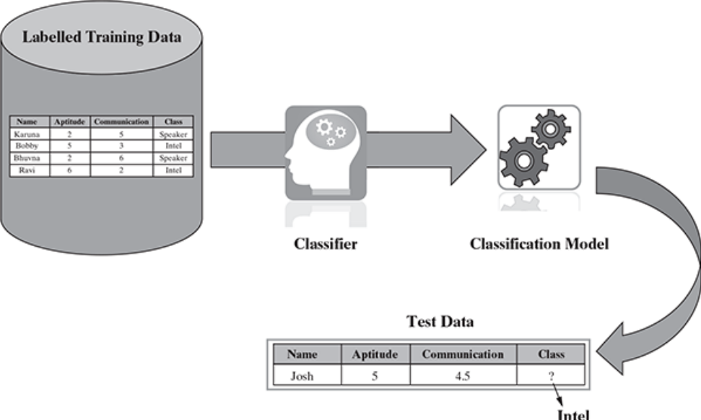
Some typical classification problems include the following:
- Image classification
- Disease prediction
- Win–loss prediction of games
- Prediction of natural calamity such as earthquake, flood, etc.
- Handwriting recognition

COMMON CLASSIFICATION ALGORITHMS

1. k-Nearest Neighbour (kNN)
2. Decision tree
3. Random forest
4. Support Vector Machine (SVM)
5. Naïve Bayes classifier

K-Nearest Neighbors (KNN) Algorithm

The K-Nearest Neighbors (KNN) algorithm is one of the simplest and most widely used machine learning algorithms for classification and regression problems. It is based on the concept of similarity (or closeness) between data point

How KNN Works:
- Training Phase:
  - Unlike other machine learning algorithms, KNN does not explicitly learn from the training data.
  - It simply stores the entire dataset and waits for new test data to make predictions.
- Prediction Phase:
  - When new data is given, KNN finds the K data points (neighbors) that are closest to the new data point.
  - It then assigns the most common class (for classification) or the average value (for regression) among these neighbors to the new data point.

Step-by-Step Working of KNN:
- Choose the number of neighbors (K):
  - A small value of K makes the model sensitive to noise.
  - A large value of K smoothens predictions but may overlook finer patterns.
- Measure the distance between data points:
  - The most commonly used distance metric is Euclidean distance, calculated as:
distance = \sqrt{(x_2 - x_1)^2 + (y_2 - y_1)^2}
- Find the K nearest neighbors:
  - Identify K closest data points based on the chosen distance metric.
- Make a prediction:
  - For classification: Assign the most frequently occurring class (majority voting).
  - For regression: Compute the average of the values of neighbors.

Advantages of KNN:
- Easy to understand and implement.
- No need for a training phase (lazy learning).
- Works well with small datasets and non-linear patterns.

Disadvantages of KNN:
- Slow for large datasets as it needs to compute distances for every query.
- Sensitive to irrelevant features and data scaling.
- Performance depends on choosing the right value of K.

Choosing the Right Value of K:
- If K=1, the model is too specific and prone to noise (overfitting).
- If K is too large, the model becomes too generalized (underfitting).
- A good practice is to try different values and use cross-validation to find the best K.

Practical Applications of KNN:
- Handwriting recognition (e.g., digit recognition).
- Recommender systems (suggesting products based on similarity).
- Credit risk analysis (approving or denying loan applications).
- Medical diagnosis (predicting diseases based on symptoms).

Support Vector Machines

- SVM is a model, which can do linear classification as well as regression.
- SVM is based on the concept of a surface, called hyperplane, which draws a boundary between data instances plotted in the multi-dimensional feature space.
- In other words, the goal of the SVM analysis is to find a plane, or rather a hyperplane, which separates the instances on the basis of their classes.
- In summary, in the overall training process, the SVM algorithm analyses input data and identifies a surface in the multi-dimensional feature space called the hyperplane.

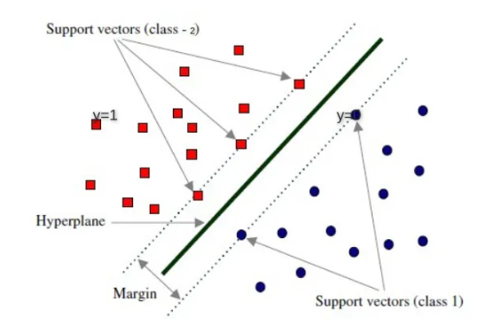

Support Vectors: Support vectors are the data points (representing classes), the critical component in a data set,which are near the identified set of lines (hyperplane).

Hyperplane and Margin: For an N-dimensional feature space, hyperplane is a flat subspace of dimension (N−1) that separates and classifies a set of data.

Identifying the correct hyperplane in SVM
1. The hyperplane should segregate the data instances belonging to the two classes in the best possible way.
2. It should maximize the distances between the nearest data points of both the classes, i.e. maximize the margin.
3. If there is a need to prioritize between higher margin and lesser
misclassification, the hyperplane should try to reduce misclassifications.

How to deal with Non-Seperable Data
- one way to deal with nonlinearly separable data is by using a slack variable and an optimization function to minimize the cost value.
- However, this is not the only way to use SVM to solve machine learning problems involving non-linearly separable data sets.
- SVM has a technique called the kernel trick to deal with non-linearly separable data.
- In the process, it converts linearly non separable data to a linearly separable data. These functions are called kernels.
- Some of the common kernel functions for transforming from a lower dimension ‘i’ to a higher dimension ‘j’ used by different SVM implementations are as follows:

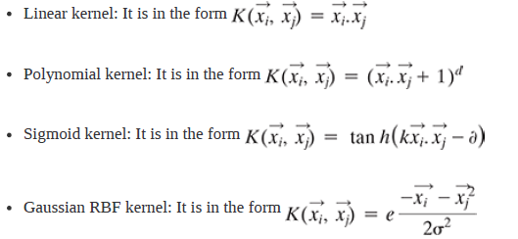
Strengths of SVM

- SVM can be used for both classification and regression.
- It is robust, i.e. not much impacted by data with noise or outliers.
- The prediction results using this model are very promising.

Weaknesses of SVM

- SVM is applicable only for binary classification, i.e. when there are only twoclasses in the problem domain.
- The SVM model is very complex – almost like a black box when it deals with a high-dimensional data set. Hence, it is very difficult and close to impossible to understand the model in such cases.
- It is slow for a large dataset, i.e. a data set with either a large number of features or a large number of instances.
- It is quite memory-intensive.

Application of SVM

SVM is most effective when it is used for binary classification,
i.e. for solving a machine learning problem with two classes.
One common problem on which SVM can be applied is in the
field of bioinformatics – more specifically, in detecting cancer
and other genetic disorders.

RandomForestClassifier

- Random forest is an ensemble classifier, i.e. a combining
classifier that uses and combines many decision tree classifiers.
- Ensembling is usually done using the concept of bagging with different feature sets. The reason for using large number of trees in random forest is to train the trees enough such that contribution from each feature comes in a number of models.
- After the random forest is generated by combining the
trees, majority vote is applied to combine the output of the
different trees.
- A simplified random forest model is depicted in
Figure. The result from the ensemble model is usually
better than that from the individual decision tree models.

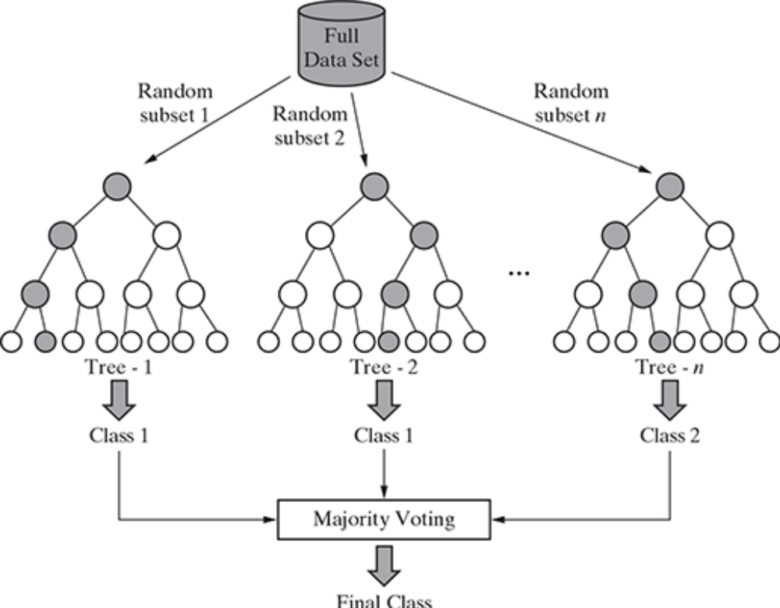
The random forest algorithm works as follows:

1. If there are N variables or features in the input data set, select a subset of ‘m’ (m < N) features at random out of the N features. Also, the
observations or data instances should be picked randomly.
2. Use the best split principle on these ‘m’ features to calculate the number of nodes ‘d’.
3. Keep splitting the nodes to child nodes till the tree is grown to the
maximum possible extent.
4. Select a different subset of the training data ‘with replacement’ to train another decision tree following steps (1) to (3). Repeat this to build and train ‘n’ decision trees.
5. Final class assignment is done on the basis of the majority votes from the ‘n’ trees.

Application of random forest

Random forest is a very powerful classifier which combines
the versatility of many decision tree models into a single
model. Because of the superior results, this ensemble model is
gaining wide adoption and popularity amongst the machine
learning practitioners to solve a wide range of classification
problems.

Logistic Regression

Logistic regression is both classification and regression
technique depending on the scenario used. Logistic regression
(logit regression) is a type of regression analysis used for
predicting the outcome of a categorical dependent variable
similar to OLS regression. In logistic regression, dependent
variable (Y) is binary (0,1) and independent variables (X) are
continuous in nature. The probabilities describing the possible
outcomes (probability that Y = 1) of a single trial are modelled
as a logistic function of the predictor variables.
- The goal of logistic regression is to predict the likelihood that Y is equal to 1 (probability that Y = 1 rather than 0) given certain values of X.
- The logistic formulae are stated in terms of the probability that Y = 1, which is referred to as P.The probability that Y is 0 is 1 –
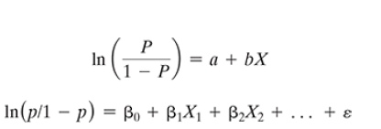

Assumptions in logistic regression

The following assumptions must hold when building a logistic
regression model:
- There exists a linear relationship between logit function and independent variables
- The dependent variable Y must be categorical (1/0) and take binary value,e.g. if pass then Y = 1; else Y = 0
- The data meets the ‘iid’ criterion, i.e. the error terms, ε, are independent from one another and identically distributed
- The error term follows a binomial distribution [n, p]
n = # of records in the data, p = probability of success (pass, responder)
UNSUPERVISED LEARNING -Clustering

- Unsupervised learning is a machine learning concept where
the unlabelled and unclassified information is analysed to
discover hidden knowledge.
- The algorithms work on the data without any prior training, but they are constructed in such away that they can identify patterns, groupings, sorting order, and numerous other interesting knowledge from the set of data.
- We will discuss two methods for explaining the principle underlying unsupervised learning – Clustering and Association Analysis.
- Clustering is a broad class of methods used for discovering unknown subgroups in data,which is the most important concept in unsupervised learning.
- Another technique is Association Analysis which identifies a
low-dimensional representation of the observations that can
explain the variance and identify the association rule for the
explanation.

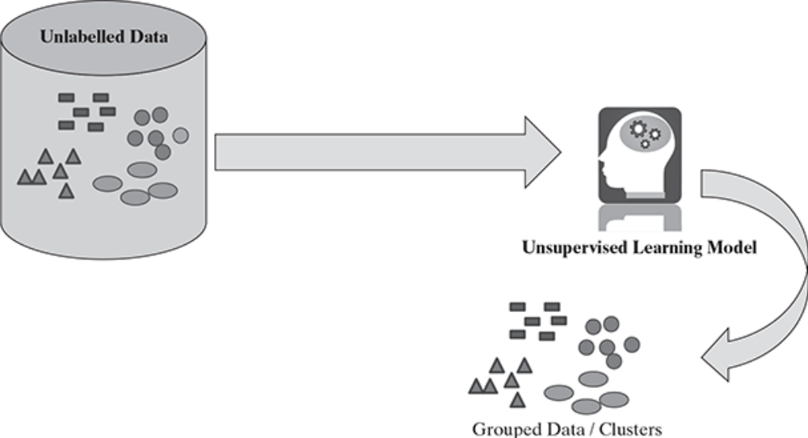

Clustering
Clustering refers to a broad set of techniques for finding subgroups, or clusters, in a data set on the basis of the characteristics of the objects within that data set in such a manner that the objects within the group are similar (or related to each other) but are different from (or unrelated to) the objects from the other groups.

Different types of clustering techniques
The major clustering techniques are
- Partitioning methods,
- Hierarchical methods, and
- Density-based methods.

1.Partitioning Methods

Two of the most important algorithms for partitioning-based
clustering are k-means and k-medoid.

i.)K-means - A centroid-based technique
- This is one of the oldest and most popularly used algorithm for
clustering.
- The principle of the k-means algorithm is to assign each of
the ‘n’ data points to one of the K clusters where ‘K’ is a userdefined parameter as the number of clusters desired.
- The objective is to maximize the homogeneity within the clusters and also to maximize the differences between the clusters.
- The homogeneity and differences are measured in terms of the
distance between the objects or points in the data set.

Algorithm shows the simple algorithm of K-means

Step 1: Select K points in the data space and mark them as initial centroids
loop
Step 2: Assign each point in the data space to the nearest centroid to form K clusters
Step 3: Measure the distance of each point in the cluster from the centroid
Step 4: Calculate the Sum of Squared Error (SSE) to measure the quality of the clusters
Step 5: Identify the new centroid of each cluster on the basis of distance between points
Step 6: Repeat Steps 2 to 5 to refine until centroids do not change
end loop

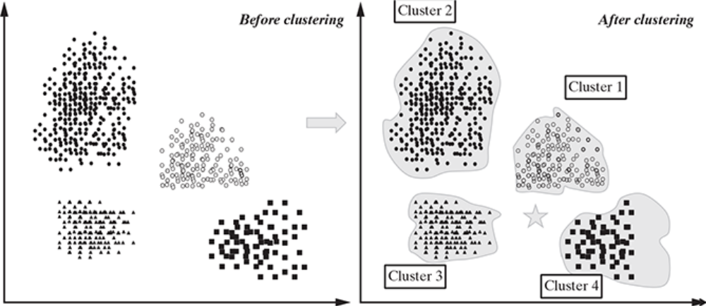
FIG. Clustering concept – before and after clustering

Choosing appropriate number of clusters
One of the most important success factors in arriving at correct
clustering is to start with the correct number of cluster
assumptions. Different numbers of starting cluster lead to
completely different types of data split.
Elbow method
This method tries to measure the homogeneity or
heterogeneity within the cluster and for various values of ‘K’
and helps in arriving at the optimal ‘K’. From Figure 9.5, we
can see the homogeneity will increase or heterogeneity will
decrease with increasing ‘K’ as the number of data points
inside each cluster reduces with this increase

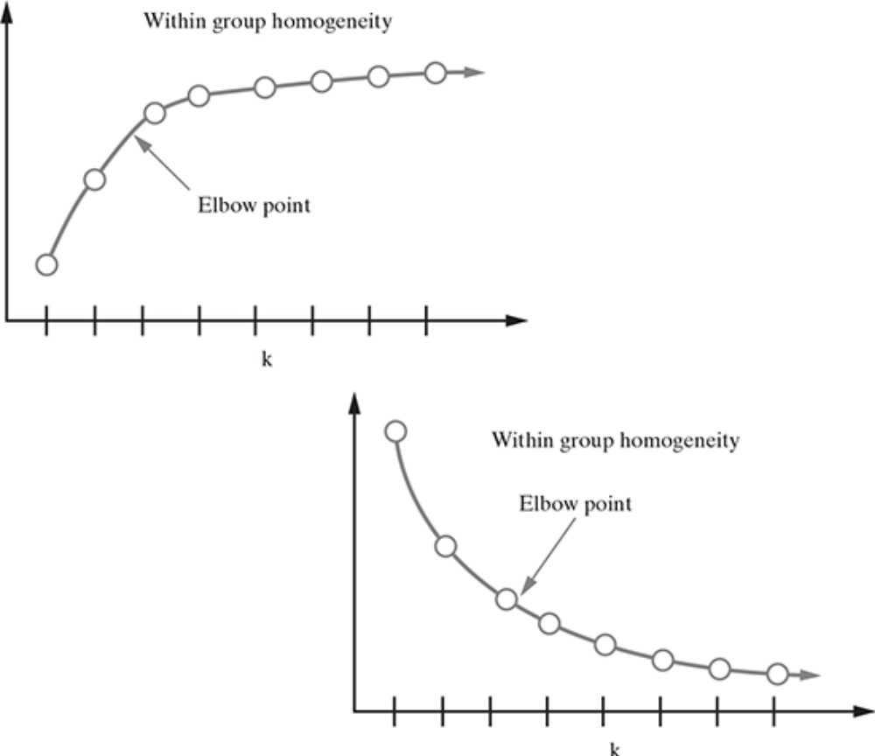

FIG. Elbow point to determine the appropriate number of clusters

